**“Problem Solving with Computer”**

**ASSIGNMENT**

**I**

**Prepared by:** Srijal Dangol **Submitted To:** Ashim Sir

**Roll Number:** 17 **Subject:** C Programming

**Shift:** Morning

**BscCSIT079**

1. **Write an algorithm and flowchart to display sum of two numbers.**

* Algorithm

Step 1: START

Step 2: Read any two numbers A and B.

Step 3: SUM = A+B

Step 4: Display the sum of two numbers in SUM.

Step 5: END

* Flowchart

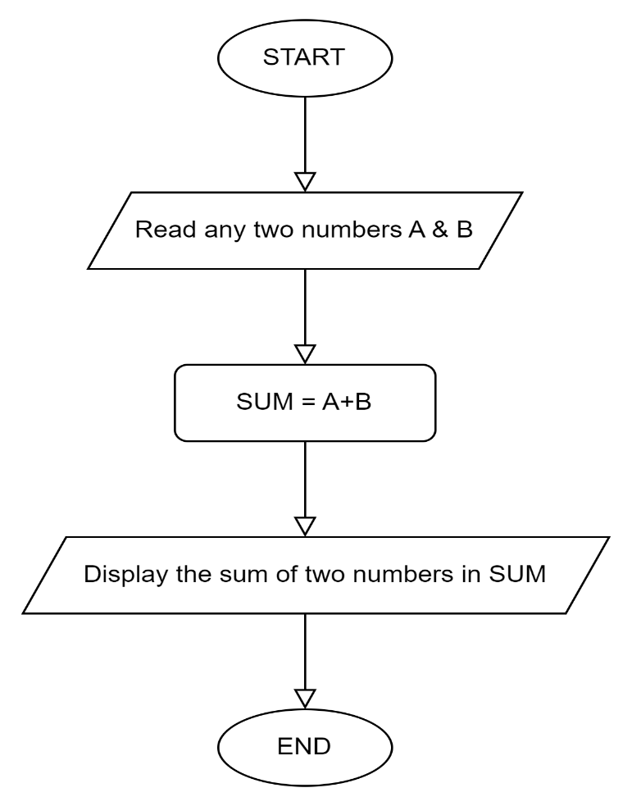

1. **Write an algorithm and flowchart to display if the number is positive or negative.**

* Algorithm

Step 1: START

Step 2: Read any numbers N.

Step 3: If N>0 then move to step 4 otherwise move to step 5.

Step 4: Display the number is positive.

Step 5: Display the number is negative.

Step 6: END

* Flowchart

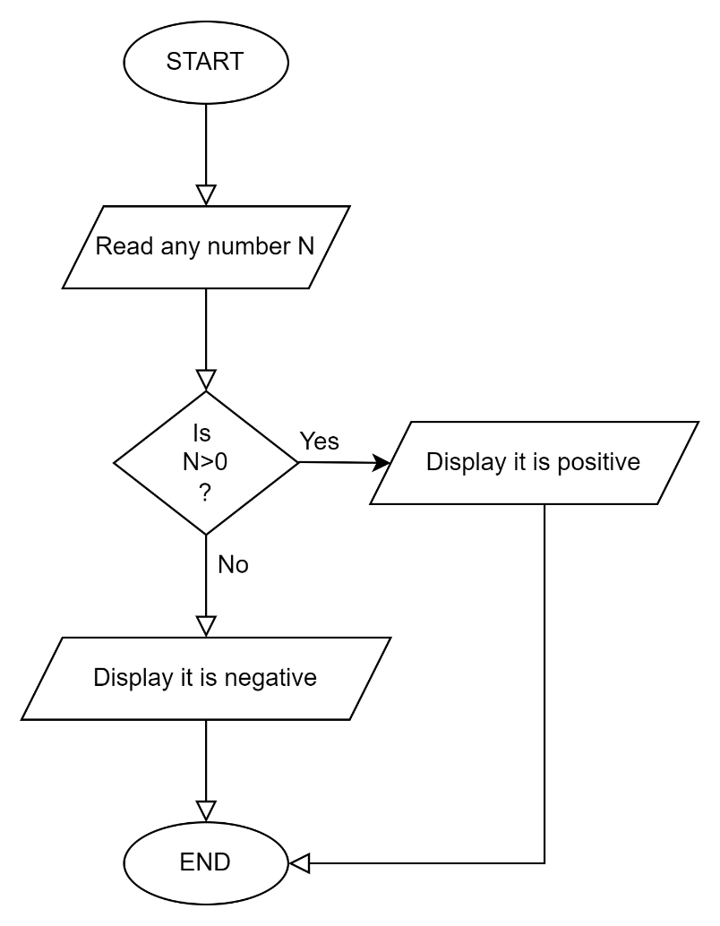

1. **Write an algorithm and flowchart to display whether the number is even or odd.**

* Algorithm

Step 1: START

Step 2: Read any number N.

Step 3: If N%2==0 then move to step 4 otherwise move to step 5.

Step 4: Display the number is even.

Step 5: Display the number is odd.

Step 6: END

* Flowchart

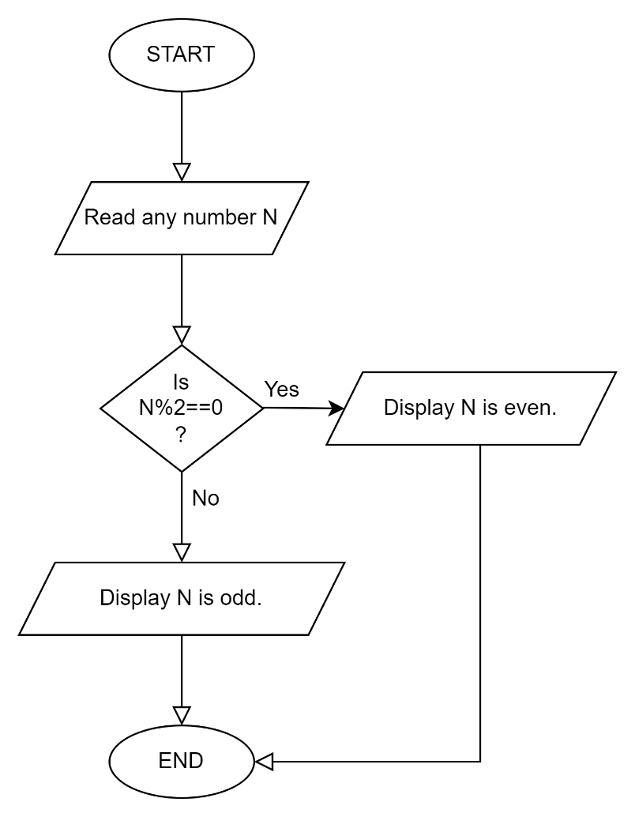

1. **Write an algorithm and flowchart to read three numbers and print the greatest number.**

* Algorithm

Step 1: START

Step 2: Read any three numbers X, Y & Z.

Step 3: If X>Y & X>Z then move to step 4 otherwise move to step 5.

Step 4: Display X is the greatest number.

Step 5: If Y>X & Y>Z then move to step 6 otherwise move to step 7.

Step 6: Display Y is greatest number.

Step 7: Display Z is greatest number.

Step 6: END

* Flowchart

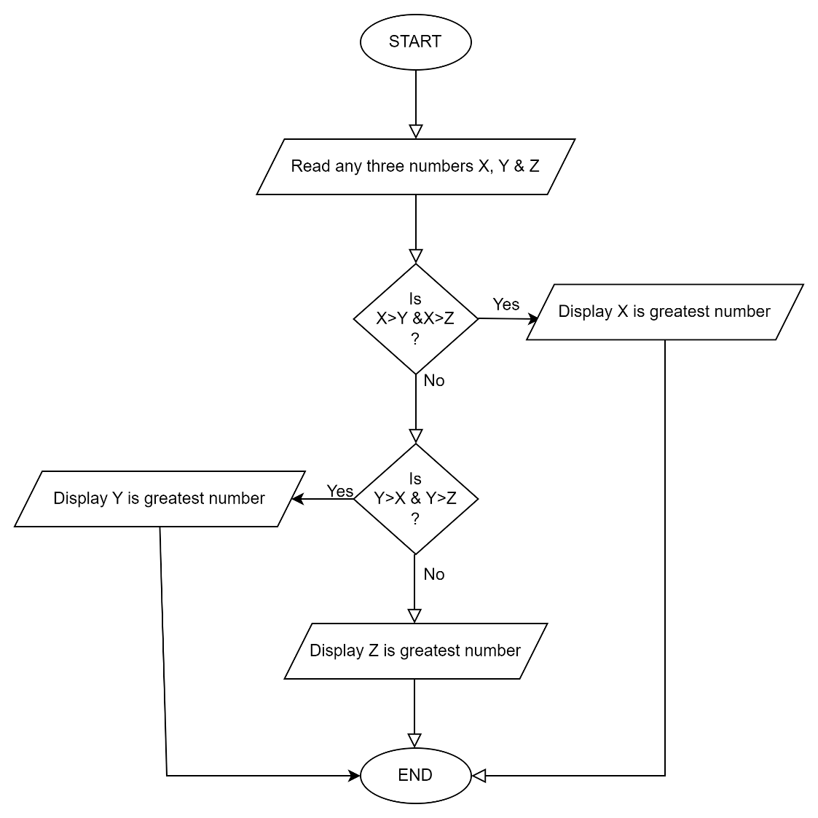

1. **Write an algorithm and flowchart to find the sum of the series 1+2+3+4…… up to entered n numbers.**

* Algorithm

Step 1: START

Step 2: Read any number N.

Step 3: Initialize I = 1 and sum = 0.

Step 4: If I < N go to step 8 end if

Step 5: sum = sum + I

Step 6: I = I + 1

Step 7: Move to step 4.

Step 8: Display value of sum.

Step 9: END

* Flowchart

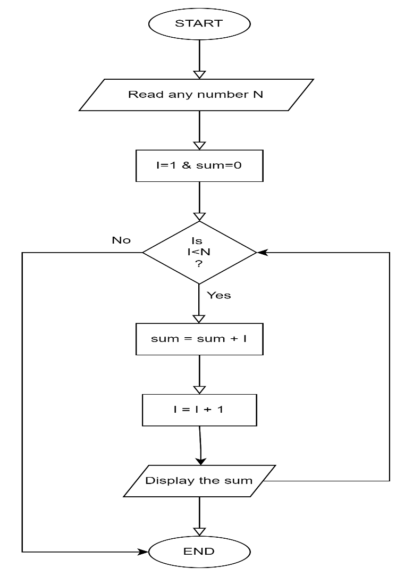

1. **Write an algorithm and flowchart to display factorial of a given number N.**

* Algorithm

Step 1: START

Step 2: Read any three numbers N where N>1 else display it doesn’t exist its factorial.

Step 3: Initialize I = 1, I <= N, fact = 1 and move to step 4 else move to step 7.

Step 4: fact = fact * I

Step 5: I = I + 1 and move to step 3.

Step 6: Display the value in fact.

Step 7: END

* Flowchart

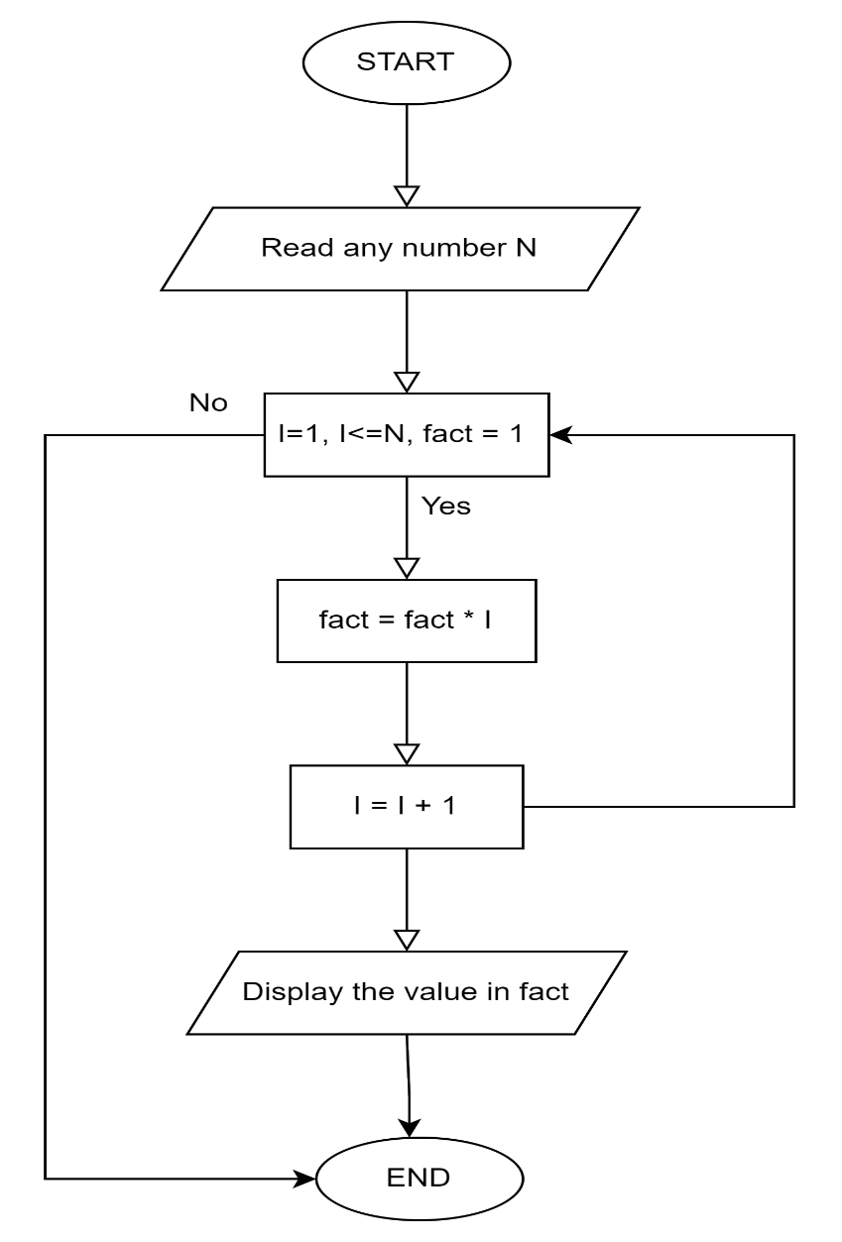

1. **Write an algorithm and flowchart to read first 20 number and display only sum of even numbers.**

* Algorithm

Step 1: START

Step 2: Read a number N = 20 and Initialize I = 1 and SUM = 0.

Step 3: If I % 2== 0 then go to step 5 else go to step 6.

Step 4: SUM = SUM + I

Step 5: I =I + 1

Step 6: If I <=N then move to step 3.

Step 7: Display SUM.

Step 8: END

* Flowchart

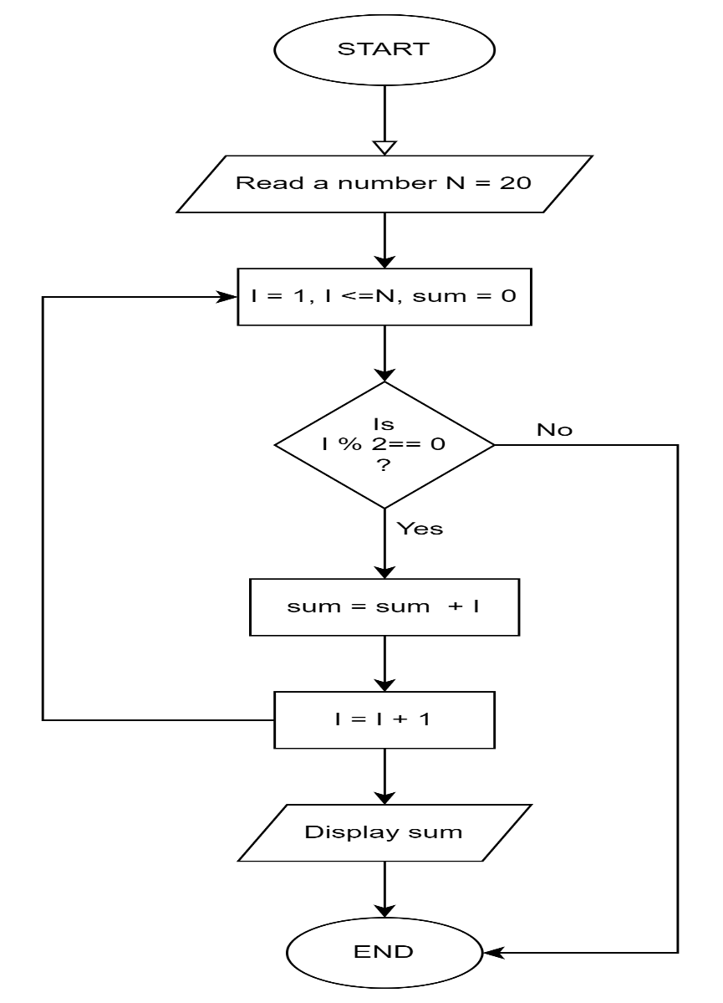

1. **Write an algorithm and flowchart to read a number n and display all of its divisors.**

* Algorithm

Step 1: START

Step 2: Read any number N.

Step 3: Initialize I = 1, if I<= N move to step 4 else go to step 6.

Step 4: If N % I == 0 then display all of its divisors else do nothing.

Step 5: I = I + 1 and go to step 3.

Step 6: END

* Flowchart

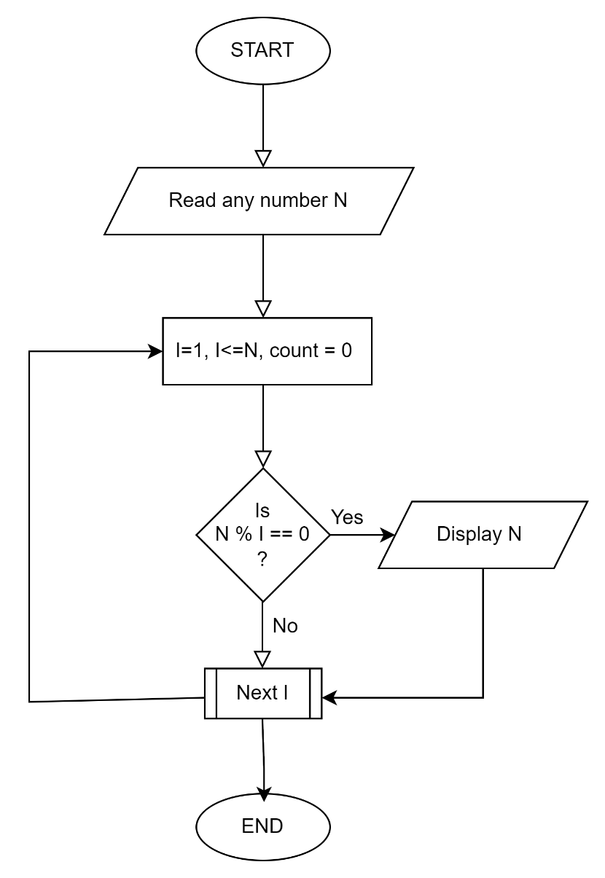

1. **Write an algorithm and flowchart which display if number is prime or not.**

* Algorithm

Step 1: START

Step 2: Read any number N and initialize I = 1 and count = 0.

Step 3: If I <= N go to step 4 otherwise go to step 7.

Step 4: If N % I == 0 then count = count + 1 else do nothing.

Step 5: I = I + 1, go to step 3.

Step 6: If count == 2 then N is prime else

Step 7: Display N is not prime.

Step 6: END

* Flowchart

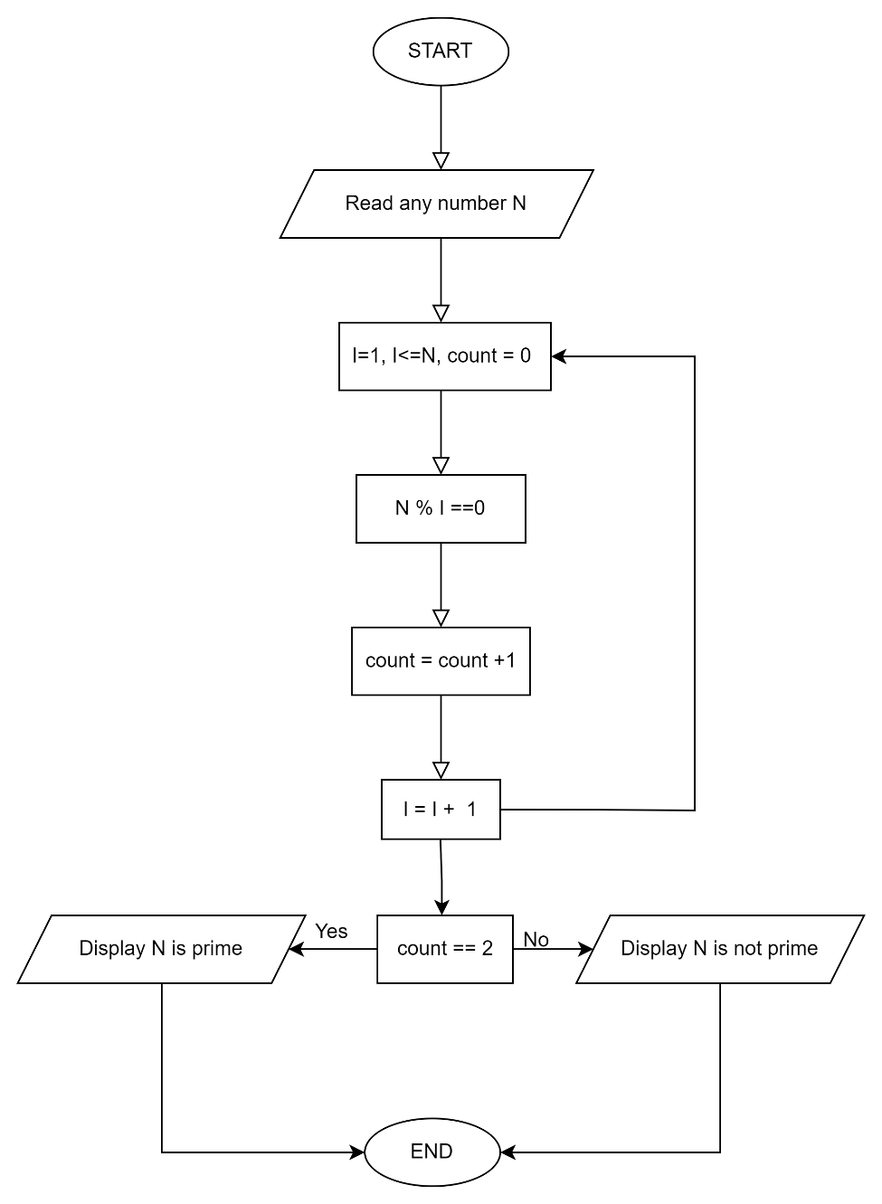

1. **Write short note on one of the following topic a. Boston Dynamics b. Palantir Technologies c. Twitter d. Viber e. Elon Musk**

* Viber

Viber is a [VoIP](https://www.techtarget.com/searchunifiedcommunications/definition/VoIP) and [instant messaging](https://www.techtarget.com/searchunifiedcommunications/definition/instant-messaging)application with [cross-platform](https://www.techtarget.com/searchmobilecomputing/definition/cross-platform-mobile-development) capabilities that allows users to exchange audio and video calls, stickers, group chats, and instant voice and video messages. It Is a product of Rakuten Viber, a multinational internet company headquartered in Setagaya-ku, Tokyo, Japan. Messages sent over Viber are protected with end-to-end [encryption](https://www.techtarget.com/searchsecurity/definition/encryption). The app is popular for users who want to hold public and private conversations, as well as play games with other users and access the service via desktop. Viber is compatible with voice assistants such as Google Assistant and Siri, as well as the contacts list in a user’s phone. Viber’s instant messaging includes features like the capacity to share photos, [GIFs](https://www.techtarget.com/whatis/definition/animated-GIF-Graphics-Interchange-Format), stickers, videos and emoticons. Connecting desktop and smartphone chat, Viber supports iOS, Android, Windows XP and up, Mac OS 10.7 and up, as well as [Linux](https://www.techtarget.com/searchdatacenter/definition/Linux-operating-system) [Fedora](https://www.techtarget.com/searchdatacenter/definition/Fedora) and [Ubuntu](https://www.techtarget.com/searchdatacenter/definition/Ubuntu). The software also enables switching calls and chats between mobile and desktop. Users who speak different languages can converse with real-time translation features. By tapping a block of text, the user can choose a language and instantly translate the text.

Viber supports extensions for capabilities that allow users to do more without leaving chat windows. Extensions exist for finding restaurants, performing searches and sharing music and video. The chat program offers [direct marketing](https://www.techtarget.com/searchcustomerexperience/definition/direct-marketing) to help businesses attract users with promotional opportunities like stickers, ads, communities and direct marketing messages. When customers are interested, transitioning from marketing to selling is enabled with [e-commerce integration](https://www.techtarget.com/searchcio/definition/e-commerce). Viber has over a billion users and supports over two million interactions every minute, according to the company. Most of Viber’s features are free, with some exceptions including calls made to landlines, international calls, and calls made to cell phones that do not have the Viber app.